# How to create the ADAL Binding Library

Document on how to create the ADAL Binding library for iOS Library using Xamarin studio.

High level steps:

* Building iOS ADAL Library
* Creating the binding project

### Building iOS ADAL Library

1. Open the **Terminal** and clone ADAL Library from GitHub repository.

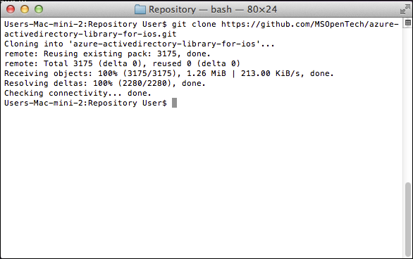

Cloning repository

1. Navigate to the **ADALiOS** folder inside the repository.
2. Execute **xcodebuild** command with the following flags to build the library for a specific architecture.

xcodebuild -project ADALiOS.xcodeproj -target ADALiOS-sdk iphonesimulator -configuration Release clean build

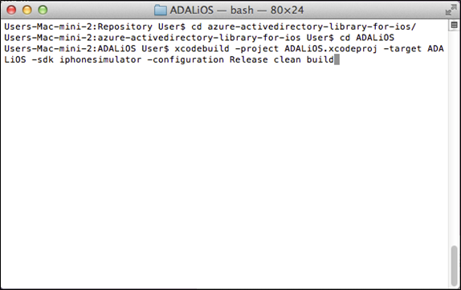

XCodebuild command

1. Go the folder where the library was created, rename the .a file and move it to a binaries folder.

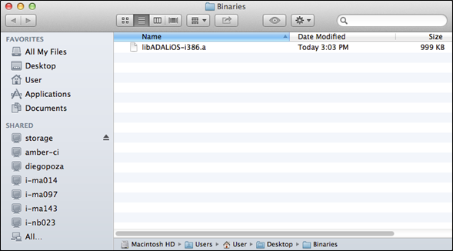

File renamed and moved

1. Repeat the previous 2 steps, but using the following commands

xcodebuild -project ADALiOS.xcodeproj -target ADALiOS-sdk iphoneos -arch armv7 -configuration Release clean build

xcodebuild -project ADALiOS.xcodeproj -target ADALiOS-sdk iphoneos -arch armv7s -configuration Release clean build

1. You should have three binary files (one per architecture) inside the **binaries** folder.
2. Inside the terminal, change the directory to the **Binaries** folder where the three files are located.
3. Execute the following **lipo** command to create a **Universal** **Binary**.

lipo -create -output [OUTPUT-NAME].a [FIRST-BINARY-RENAMED].a [SECOND-BINARY-RENAMED].a [THIRD-BINARY-RENAMED].a

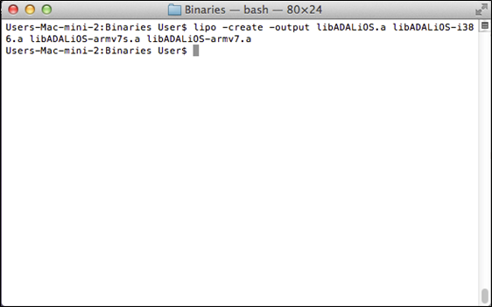

Lipo command to create universal binary

1. You will find the universal binary in the same folder.

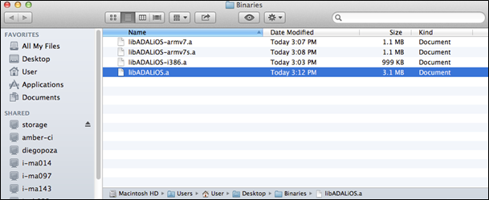

Universal binary created

### Creating the binding project

1. Open **Xamarin** **Studio**.
2. In the **Solutions** pane, click on the **New…** button.

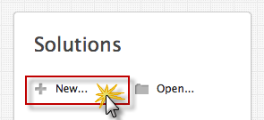

New button

1. In the **New Solution** dialog box, select **iOS** **Binding** **Project**, name it **ADALBinding** and click **OK**.

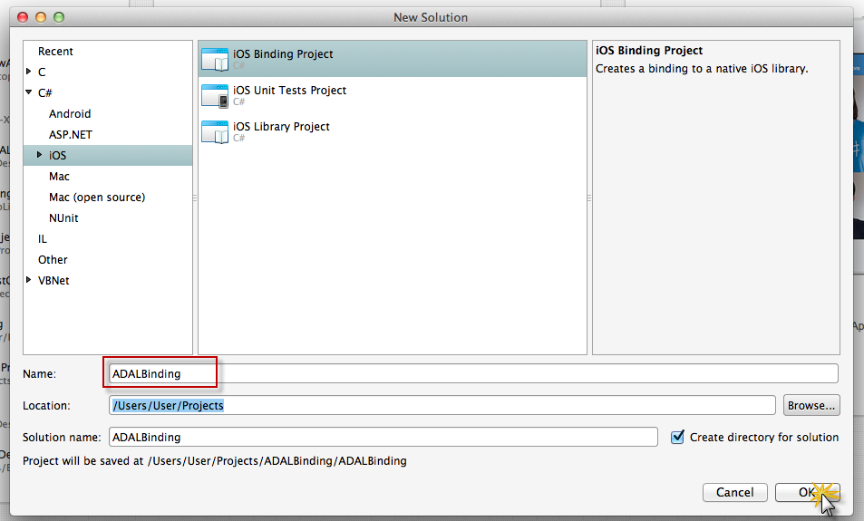

New solution dialog box

1. Right-click in the **ADALBinding** solution, navigate to **Add** and click **Add Files…**.

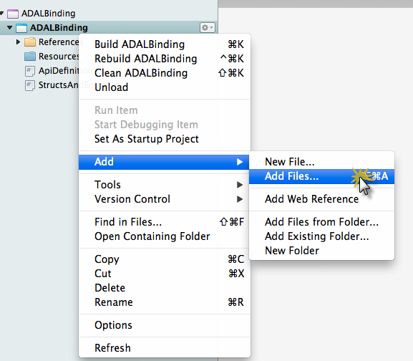

Add Files... button

1. Browse to the **Binaries** folder and select the universal binary you created with the **lipo** command.

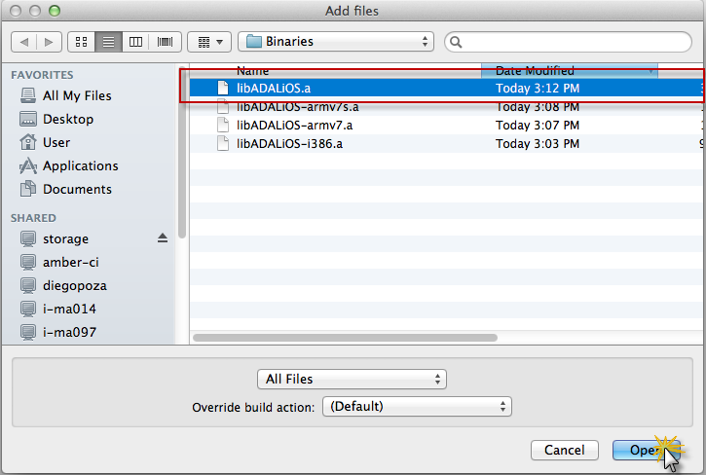

Add files dialog box

1. Leave the **Copy** action in the dialog box and click **OK**.

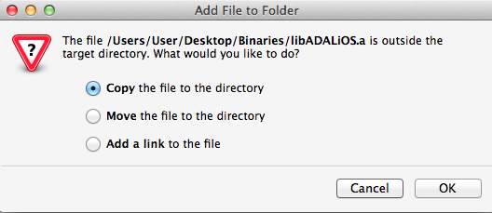

Add file to folder dialog box warning

1. Replace the **ApiDefinition.cs** file with the **ApiDefinition** provided.
2. Replace the **StructsAndEnums.cs** file with the **StructAndEnums** provided.
3. Right click in the solution and click **Build ADALBinding** to generate the DLL.

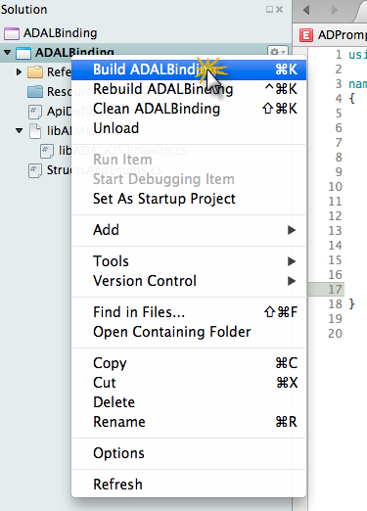

Build solution

1. You can now import the generated DLL into your project.